**GOVERNMENT POLYTECHNIC, HINGOLI**



**Sixth Semester**

**(Year: 2022-23)**

Micro Project

**Programming With Python (22616)**

Title of the Project

**“NETFLASK”**

**Branch: Computer Engineering (CO6I)**

Members of the Group

|  |  |  |  |  |
| --- | --- | --- | --- | --- |
| **Sr. No.** | **Roll No.** | **Enrollment No.** | **Exam Seat No.** | **Name of the Student** |
| 1 | 3106 | 2011630007 | 448284 | Rohan Prakash Pawar |

**Guided by**

**Prof. P. H. Gutte**

**MAHARASHTRA STATE BOARD OF TECHNICAL EDUCATION, MUMBAI**



**CERTIFICATE**

*This is to certify that this Micro-Project contains the bonafied work of following students of 6th Sem Diploma in Computer Engineering, of* ***Government Polytechnic, Hingoli*** *for the session* ***2022-23.*** *They have completed their Micro- project report entitled* ***"NETFLASK”*** *under the guidance of* ***Mr. P. H. Gutte.*** *This Project report is being submitted to MSBTE, Mumbai, in the partial fulfillment for the Diploma in Engineering*

|  |  |  |  |  |
| --- | --- | --- | --- | --- |
| **Sr. No.** | **Roll No.** | **Enrollment No.** | **Exam Seat No.** | **Name of the Student** |
| 1 | 3106 | 2011630007 | 448284 | Rohan Prakash Pawar |

Prof.P. H. GutteProf. A. T. Adhave Dr. Ashok Upadhyay

**Guide HOD Principal**

**Place: Hingoli**

**Date:**

**ACKNOWLEDGEMENT**

It is my great pleasure to acknowledge my guide **Prof. P. H. Gutte,** lecturer in **Government Polytechnic, Hingoli.** His valuable guidance, constant inspiration, unending support helped me a lot of focus my views in proper perspective.

Our sincere and whole hearted thanks to **Dr. Ashok Updhyay**, principal **Government Polytechnic, Hingoli** for inspiring us to achieve highest goal. I’m thankful to HOD **Prof. A.T. Adhave** for providing me this platform. Last but not least I am also thankful to my parents and friends who helped me a lot in finalizing the project within limited time frame.

**Thank you**

**Name of the Student**

Rohan Prakash Pawar

|  |  |  |  |  |  |  |
| --- | --- | --- | --- | --- | --- | --- |
| **Micro Project Evaluation Sheet**    **Name of Student: Rohan Prakash Pawar Enrollment No: 2011630007**  **Name of Program :** Computer Engineering  **Semester: 6th**  **Course Title:** Programming With Python **Course Code: 22616**  **Title of Micro Project: NETFLASK**    **Learning Outcomes Achieved**:   1. Learnt to work with various modules, packages and Frameworks. 2. Step wise Progressive Work Flow and Time management. 3. Learnt Version Controlling for a project. 4. Learnt to Integrate various experiences and technologies in current project. 5. Got a better understanding of how Python works. | | | | | | |
| **Sr No** | **Characteristic to be Assessed** | **Poor**  **Marks**  **(1-3)** | **Average**  **Marks**  **(4-5)** | **Good**  **Marks**  **(6-8)** | **Excellent**  **Marks**  **(9-10)** | **Sub Total** |
| **(A) Process and Product Assessment (6 Marks)** | | | | | | |
| 1 | Relevance to the Course |  |  |  |  |  |
| 2 | Literature Review/Information Collection |  |  |  |  |
| 3 | Completion of the Target as per Project Proposal |  |  |  |  |
| 4 | Analysis of Data & Representation |  |  |  |  |
| 5 | Quality of Prototype/Model |  |  |  |  |
| 6 | Report Preparation |  |  |  |  |
| **(B) Individual Presentation/Viva (4 Marks)** | | | | | | |
| 7 | Presentation |  |  |  |  |  |
| 8 | Viva |  |  |  |  |

|  |  |  |
| --- | --- | --- |
| **Sr no.** | **Content** | **Page no.** |
| **PART A** | | |
| 1 | Introduction | 6 |
| 2 | Features | 6 |
| 3 | Architecture | 7 |
| 4 | Design | 8 |
| 5 | Challenges and Limitations | 8 |
| **PART B** | | |
| 6 | Modules | 9 |
| 7 | Installation | 9 |
| 8 | Usage | 9 |
| 9 | Screenshots | 10 |
| 10 | Login | 11 |
| 11 | Dependencies | 11 |
| 12 | Conclusion | 11 |
| 13 | Reference | 12 |

**INDEX**

**NETFLASK**

**PART A**

**Introduction:**

Netflask is a web application developed using Python Flask framework that allows users to perform basic network troubleshooting and information gathering tasks. The application provides features like ping test, DNS and IP lookup, traceroute, port scanning, and web scraping. The primary goal of this project is to provide a user-friendly and efficient way of troubleshooting network issues and gathering information related to networks.

**Features:**

Netflask provides the following features:

1. **Ping Test:**

The ping test feature allows users to check if a given host or IP address is reachable on the network. The user can enter the host or IP address and the number of packets to be sent. The application then sends the packets to the specified host and displays the results.

1. **DNS and IP Lookup:**

The DNS and IP lookup feature allows users to find the IP address of a domain name or the domain name of an IP address. The user can enter the domain name or IP address, and the application returns the corresponding result.

1. **Traceroute:**

The traceroute feature allows users to trace the route taken by packets from the source to the destination. The user can enter the destination IP address, and the application displays the path taken by packets and the response time of each hop.

1. **Port Scanner:**

The port scanner feature allows users to scan for open ports on a given IP address or host. The user can enter the IP address or host, and the application scans for open ports and displays the results.

**Architecture:**

Netflask is built using Python Flask, a micro web framework that allows developers to build web applications quickly and efficiently. The application follows the Model-View-Controller (MVC) architecture, where the model represents the data, the view represents the user interface, and the controller handles user input and manages the interaction between the model and the view.

The application uses various Python modules like requests, socket, and subprocess to perform network-related tasks like web scraping, DNS and IP lookup, and traceroute.

**Design:**

The user interface of Netflask is designed to be simple and easy to use. The application provides a single-page interface where the user can select the desired feature from the menu and enter the required parameters. The application then displays the results on the same page.

The design of the application follows the Material Design guidelines, which provide a clean and modern look to the interface. The color scheme of the application is kept simple and elegant, with a grey and white color scheme that provides a soothing and professional look.

**Challenges and Limitations:**

One of the major challenges faced during the development of Netflask was to handle errors and exceptions that can occur during network-related tasks. The application handles errors like DNS resolution failures, network timeouts, and connection errors gracefully, and displays informative error messages to the user.

Another limitation of Netflask is that it can only perform basic network troubleshooting and information gathering tasks. The application cannot handle more advanced tasks like network topology mapping or intrusion detection.

________________________________________________________

**PART B**

**Modules:**

• Ping Test: Tests the reachability of a host by sending ICMP packets.

• DNS and IP Lookup: Retrieves DNS information and performs a reverse lookup for a given IP address.

• Traceroute: Traces the path that packets take from the server to a specified host.

• Port Scanner: Scans for open ports on a specified host.

**Installation:**

1. Clone this repository to your local machine.

2. Create a virtual environment: **python -m venv env**

3. Activate the virtual environment: **source env/bin/activate** (on Linux/Mac) or **.\env\Scripts\activate** (on Windows).

4. Install the required dependencies:

**pip install -r requirements.txt**.

5. Start the Flask development server: **python app.py**

6. Open your web browser and navigate to <http://localhost:5000>.

**Usage:**

The home page of the web app provides links to each of the modules. Simply click on the desired module and follow the on-screen instructions to enter the necessary input.

**Screenshots of Output:**

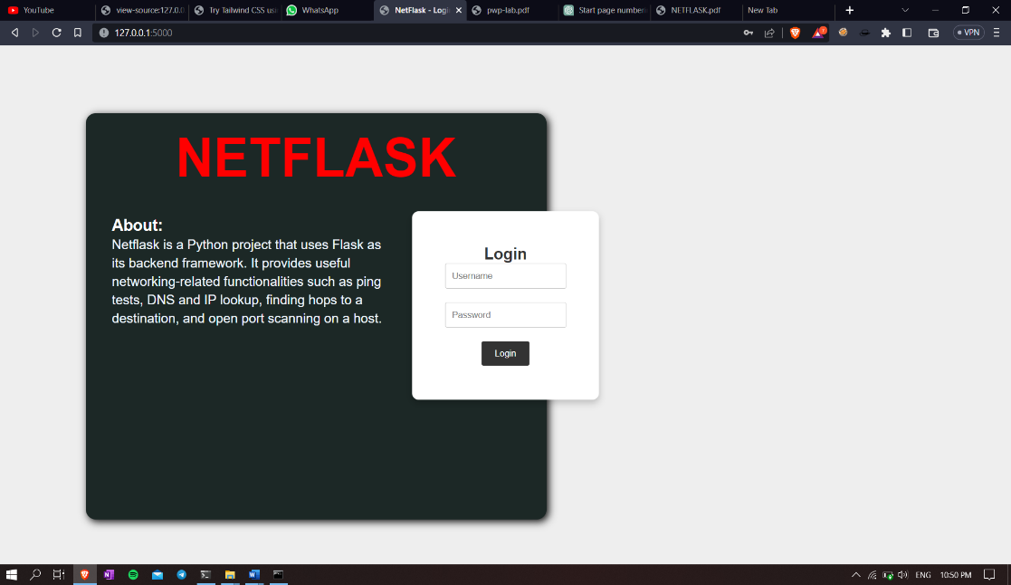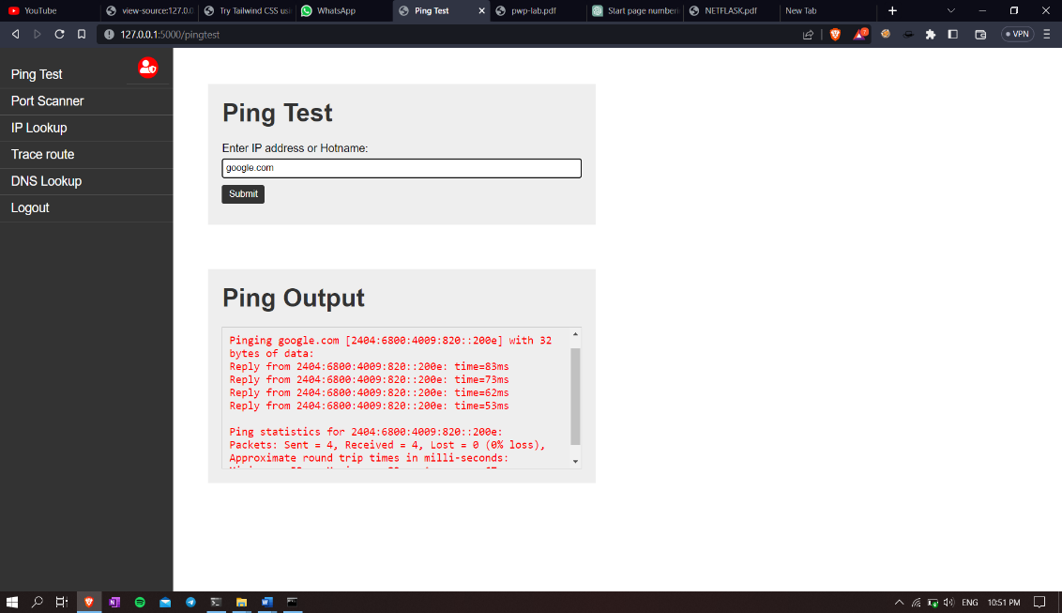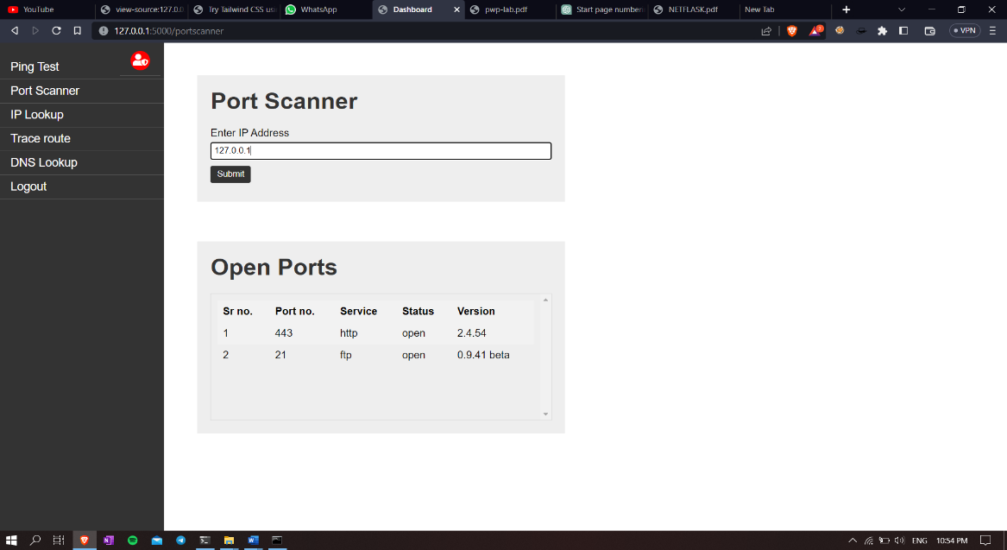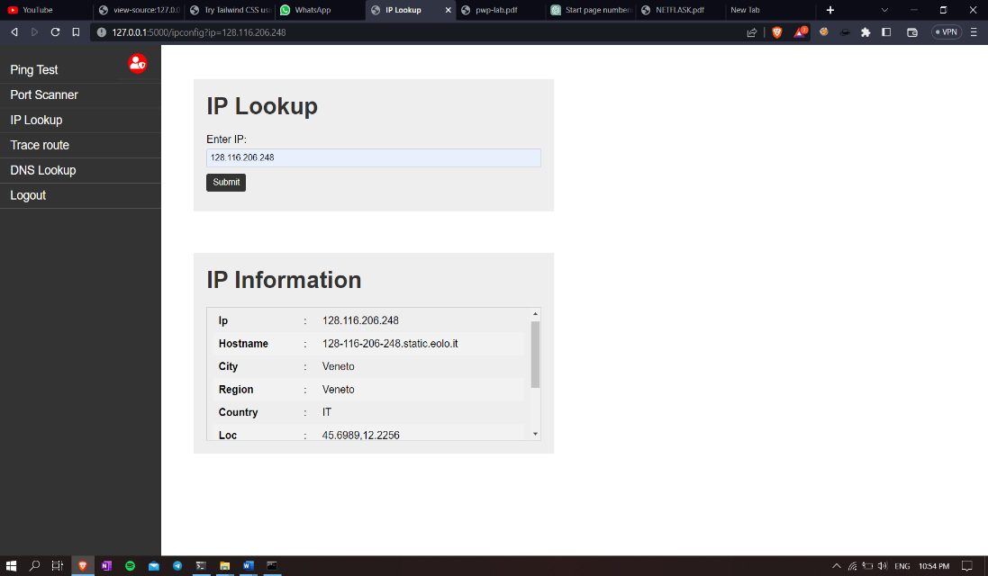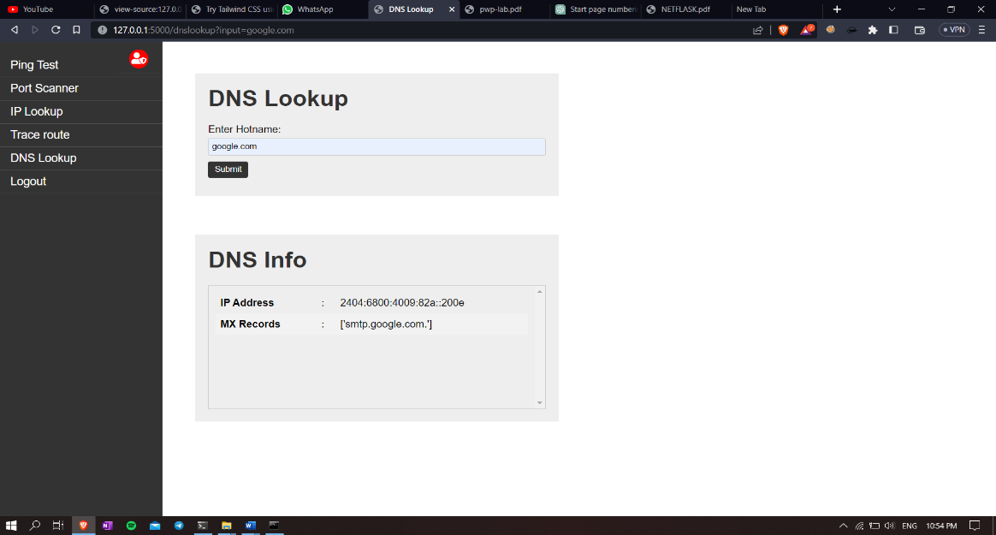

**Login:**

The default login credentials are **rohan:1234.** Please change the password after logging in for the first time.

**Dependencies:**

This project requires the following dependencies:

• Flask==2.1.2

• Jinja2==3.0.2

• Werkzeug==2.0.2

• argparse==1.4.0

• dnspython==2.1.0

• nmap==0.6.7

• requests==2.26.0

• six==1.16.0

• urllib3==1.26.7

**Conclusion:**

In conclusion, Netflask is a simple and efficient web application that provides basic network troubleshooting and information gathering functionality. The application is built using Python Flask and follows the MVC architecture. The user interface of the application is designed to be simple and easy to use, and the application handles errors gracefully. While the application has its limitations, it can be a useful tool for users who need to perform basic network troubleshooting and information gathering tasks.

**References:**

1. Chat GPT3 <https://chat.openai.com>
2. Tutorials Point https://tutorialspoint.com

**Student Details:**

|  |  |  |  |  |
| --- | --- | --- | --- | --- |
| **Sr. No.** | **Roll No.** | **Enrollment No.** | **Exam Seat No.** | **Name of the Student** |
| 1 | 3106 | 2011630007 | 448284 | Rohan Prakash Pawar |

**\*\*\* End of the report \*\*\***